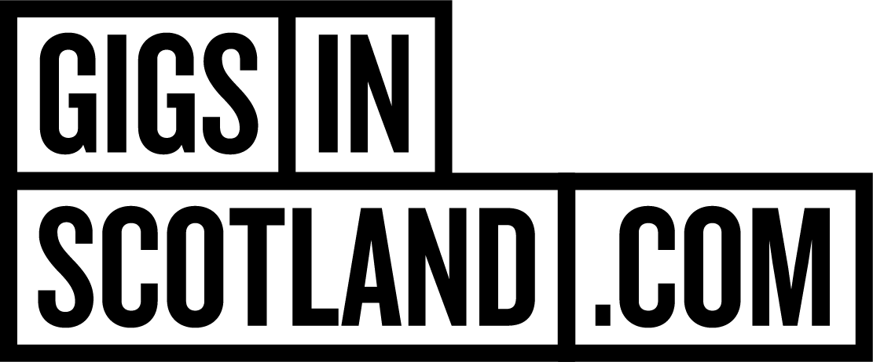
PRIZE PROMOTION NOTICE

1. This Prize Promotion Notice sets out the details of the Gigs in Scotland The Hives Giveaway (the "Prize Promotion") being run by DF Concerts & Events (“Our”,
"Us" and "We").

2. The Prize Promotion is subject to these terms and Our general terms and conditions
for Prize Promotions ("Prize Promotion Terms and Conditions"), which can be found at:
https://www.gigsinscotland.com/info-page/competition-tcs

3. The Prize Promotion will be run through https://www.instagram.com/gigsinscotland/ and https://www.facebook.com/Gigsinscotland

4. To enter the Prize Promotion, you must be:
a) resident in the United Kingdom;
b) able to comply with these terms and all the Prize Promotion Terms and
Conditions;
c) at least 18 years old

5. To enter the Prize Promotion, you must; follow @gigsinscotland and @thehives on Instagram and/or Facebook, tag you gig partner in the comments.

6. The Prize Promotion will commence on Friday 24th October at 2pm and end on Monday 27th October at 12pm.

7. The Prize is x1 pair of tickets to The Hives Forever Forever The Hives - World Tour 2025, Wednesday, 26 Nov 2025, OVO Hydro, Glasgow and side of stage access. There will be one pair of tickets available and side of stage access for first three songs only.

8. There is one Prize available (1 pair of tickets to The Hives Forever Forever The Hives - World Tour 2025, Wednesday, 26 Nov 2025, OVO Hydro, Glasgow and side of stage access. There will be one pair of tickets available and side of stage access for first three songs only).

9. If you are the winner of the Prize Promotion ("Winner"), you will be notified by direct message and advised on how to receive the Prize. Please note that if you do not respond within 72 hours we reserve the right to select a different Winner.

10. Proof of identification may be required to claim the Prize.

11. This prize is x1 pair of tickets to The Hives Forever Forever The Hives - World Tour 2025, Wednesday, 26 Nov 2025, OVO Hydro, Glasgow and side of stage access. There will be one pair of tickets available and side of stage access for first three songs only, included in the prize promotion as defined in the Prize Promotion Terms and Conditions.

12. In the event of any inconsistency between the terms of this Prize Promotion Notice
and the Prize Promotion Terms and Conditions, the terms of this Prize Promotion Notice
shall prevail.

